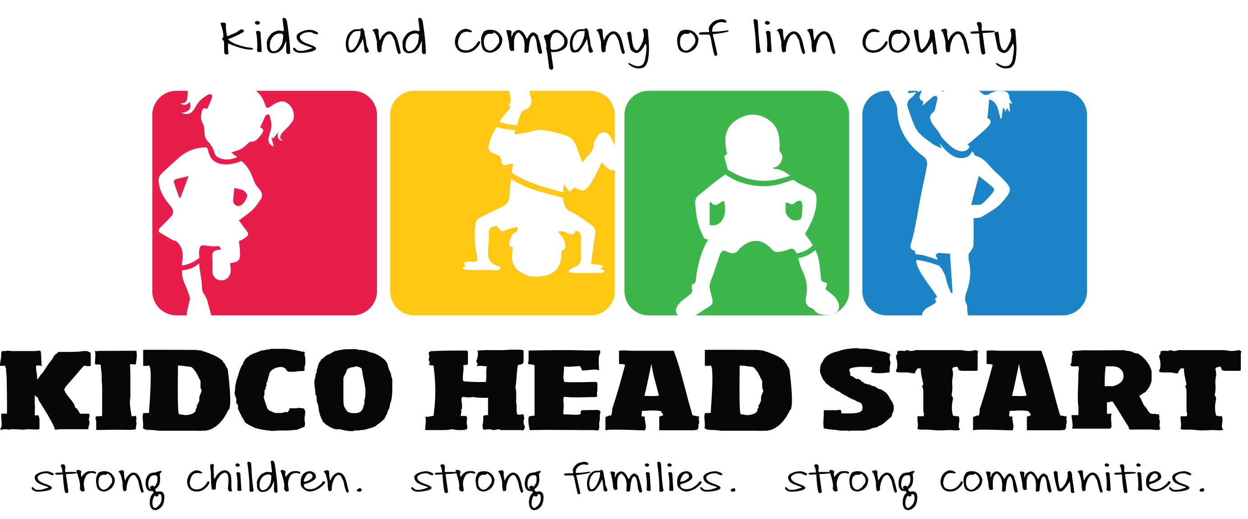

2021 SCHOLARSHIP

For Currently Enrolled Parents/Guardians and
Head Start Alumni Graduating Seniors

Due Date: March 31, 2021

SCHOLARSHIP

Each year, one applicant will be selected to receive an award of $1,000 a year for two years from the Kidco Head Start Board of Directors.

The recipient of the scholarship will be notified of the Board decision by June 1st of each year.

The recipient of the scholarship will be required to appear at a Board meeting before funds are sent to the recipient’s institution of choice. Exceptions may be considered for extenuating circumstances.

By submitting the application, the recipient agrees to have their photo taken and for their photo and essays to be featured in Kidco publication and/or as a story in a local newspaper.

CRITERIA

- Applicants must be a current Kidco Head Start parent/guardian or a Head Start graduate.

- All applicants must have a high school diploma, GED, or about to graduate with a high school diploma or GED.

- The applicant must show proof of attending or intent to attend a licensed and/or accredited institution. Proof must be one of the following: A letter indicating acceptance of admission, forms indicating current enrollment in a four-year college, a two-year college or a vocational or technical school, or a copy of the student’s application for admission if the student has not yet received confirmation of acceptance.

  - If turning in an application for admission, a confirmation of acceptance must be turned in before award can be given.

- The applicant must be attending, or planning to attend the institution at a minimum of half-time (at least 6 quarter credits a term).

- CATEGORIES: The applicant must submit a separate page of typed responses for each category listed here. Essays must be single spaced, 12 point Times New Roman Font.

- HEAD START EXPERIENCE ESSAY: Describe in one page or less, your experience with Head Start as a parent or as a Head Start child graduate. (20 points)

- GOALS/ASPIRATIONS ESSAY: Describe in one page or less, your goals and aspirations for furthering your education AND the role Head Start has played in your education. (50 points)

- REFERENCE LETTERS: The applicant must submit exactly three letters of reference, one for each type of relationship listed below. Each letter must be written by a different person. Each letter must be labeled in the top right corner indicting one of the following relationships with the applicant: (30 points)

- Teacher/Supervisor/Educator
- Personal (non-family)
- Community Member

GUIDELINES

- Applications that are filled out correctly will automatically be qualified for Oregon Head Start scholarships. If applicant does not wish to be entered for an OHSA scholarship they must provide a written statement with their Kidco scholarship application.

- Head Start graduates currently graduating from high school, or earning their GED and entering college can apply for the OSHA Scholarship by visiting the OSAC Student Portal.

- Applicants must have a high school diploma or GED, or must be senior in high school graduating the year of scholarship application.

- Scholarships submitted after the March 31, 2021 deadline will not be accepted.

- All scholarships must be submitted in English.

- Submit 3 copies of the entire scholarship application.

- Photos are not to be submitted. Applications with photos will be disqualified.

- The accumulative GPA must be 2.5 or better.

- The recipient must prove minimum of half-time enrollment (6 credits) in previous 2 quarter/terms.

- The recipient must present the Board with the name, address, and contact number of the institution to which the check should be sent. The check will be mailed to the institution by the end of September each year upon receipt of proof of enrollment from the applicant.

- To receive the second year award, the recipient must submit a complete official transcript of previous year by August 15th, 2019 to Kidco Head Start.

- If you have questions or need support in completing your application, please contact your Family Advocate or the PFCE Specialist at (541) 451-1581.

COVER PAGE
Please complete and attach this form to the front page of your application.

Name of Applicant | Date
Street Address
Mailing Address (if different)
Phone | Email
If child is currently enrolled in Head Start, please write the Center where the child attends:

If applicant is a Head Start graduate, please write the name of the program attended and include the complete address & phone number of the program:

SUBMISSION CHECKLIST
☐ Cover page (this form)
☐ Head Start Experience Essay
☐ Personal Goals/Aspirations Essay
☐ Three letters of reference, one from each category:
☐ Teacher/Supervisor/Educator
☐ Personal (non-family)
☐ Community Member
☐ Proof of acceptance to a licensed and/or accredited institution, or a copy of student’s application for admission
☐ Three copies of entire application
Submit all 3 copies of your completed application

Kidco Head Start
ATTN: Scholarship Committee
300 Market St., Suite 200
Lebanon, OR 97355

