- Call the Meeting to Order – Kandi Meyers
- Public Comment
- Reports
  - Parent, Family and Community Engagement Opportunities – Julie Lovell
  - Program Report – Laura Palma
  - Executive Director’s Report – Stephany Koehne
  - Financial Report – Kerri Godinez
  - Kids & Company Board Minutes
  - Personnel Action Report – State reps
- Attendance – Stephanie Nading
- Agenda Additions:

- Consolidated Actions (Motion)
  - Agenda Approval
  - January Meeting Minutes
- Old Business-
  - N/A
- New Business
  - Health Training: HSPPS & Head Start Act – Madeleine Sprague
- What to share at your Parent Meeting- ALL
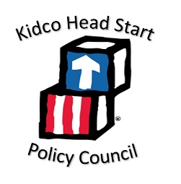
- Announcements – all
  - Community resources/events to share
  - Next Meeting Date: March 11, 2021 at 10am-noon; virtual
  - Complete Survey and In-Kind.
- Door Prize Drawing
- Adjournment (Motion)

